**Abstract**

It is a necessity to transport our assets frequently and accurately to avoid confusion in our daily , monotonous lives. Managing a large number of bags is quite tedious and therefore needs a system specifically designed for smooth handling and tracking of these bags. Airline industry is the major beneficiary of this system. The most common errors in Airline industry are mislaid, lost and wrong routed luggage. So in order to avoid the aforementioned discrepancies, we have come up with a Baggage Tracking and Handling System. It basically uses RFID /Barcode tags and a database. . We have designed a prototype at two checkpoints having both check-in and check-out processes. A well known and secure algorithm is used for the generation of RFID tags/barcodes. These are attached to baggage label which has printed details about the passenger and airline on it. The RFID/Barcode scanners at the check-out areas facilitate step by step tracking and monitoring of baggage. The baggage’s real time position is tracked and stored in a cloud using IoT scanners and the unique ID and the status is available to passengers whenever required. The same ID is to be used at check-out counters while collecting bags.The resultant system is fast, quite secure and economically viable ,in turn enhancing customer satisfaction.

**Introduction**

According to worldbank.com passenger statistics, approximately 4 billion people were transported in the world internationally on airplanes in 2017. It is evident that Airline industry in an extremely vital one. Twice, or even thrice the number of bags would be subjected to baggage handling errors in a year and can result in a huge combined loss for the passengers as well as the airline while attempting to track lost baggage with zero certainty of it being found. RFID has proven to be a boon for tracking purpose and is one of the most promising, effective and feasible technology for research. The system will constitute three components: Scanners, Tags and a Backend system to connect the two and to store the information. The tag will consist of a microchip which is assigned a unique serial number to identify the object it is attached to. It can also store other information about the trip of the bag, e.g. flight number, name of the Airline, type of luggage and so on. The operations will take place in Ultra High Frequency (UHF) range as it works well in dry-non metallic environment, suitable for aviation baggage application. The method utilizes radio waves to accomplish automatic identification and collection of data from the tag. The Scanner consists of the Radio Frequency module and the controller. It has another interface to communicate with the backend for passing into the database the information it reads from the tags. The backend application will then provide the users information about their luggage.

RFID gathers information wirelessly using the scanners and the received data is to be managed remotely. This is where the IoT comes in. With the help of IoT, we can sense and manage the objects across the network, creating possibilities for more direct integration of the physical objects into a digital system thus reducing the complexities of man handling involved with the same work.

With the information being updated automatically, users can keep a track of their belongings at all times. A common portal accessible over the internet will enable the users to request for the tracking details. The authorities can be informed if a baggage is found to be off track and it can then be taken care of manually. This paper thus proposes an IoT/RFID based baggage tracking system for improving convenience

**Related research:**

**Working and Implementation of RFIDs**

RFID tags are based on the AIDC(Automatic Identification and Data Collection) which is a technology of digitally encoding data into a chip capable of transmitting the stored data with the help of a small antenna. Passive RFID tags(without a battery) depend on scanners while Active RFID(have a battery) tags can function without them. In the proposed system, we plan on making use of passive RFID tags.

While active RFID tags can function on their own with the help of the battery within to transmit data, passive RFID tags depend on the scanners to function. When brought near a scanner, the coil generates just enough electric charge within the RFID tag to transmit the data in the RFID tag which is then captured by the scanner using radio signals.

**Programming of RFID Scanners**: Each RFID object has its own unique identification number. This can be utilized to uniquely recognize each and every tag that is ever produced. Thus, we just need to update the database and associate the tags we give the user with their luggage and flight details IN the database, not the tag.

Using technologies like windows mobile, C and .net, it is possible to manipulate information received from RFID and modify the database accordingly. The scanners can be programmed to update the location of the baggage as soon as the tag associated with it is read successfully at a certain checkpoint.

**Proposed System:**

The tags will be attached to the baggage after security checks. The baggage information such as the owner identity, flight details and airline name and number is stored in the centralized database server as well as on the tag. The scanners will have access to the internet over which they will report the data to the server. All scanners will have custom software that will process the data before sending it to the server. When the baggage passes security checks, a tag will be attached to it with details preloaded on the server. Along the journey the baggage will pass through various checkpoints with a scanner located at all of them. The scanner will read the tag and thus update the status of the baggage as well as trigger a notification to the owner. On arrival at the destination airport, the user will be provided with a unique password linked with the tag. The passenger has to show the password and only the baggages with tags matching the password will be given to the passenger.

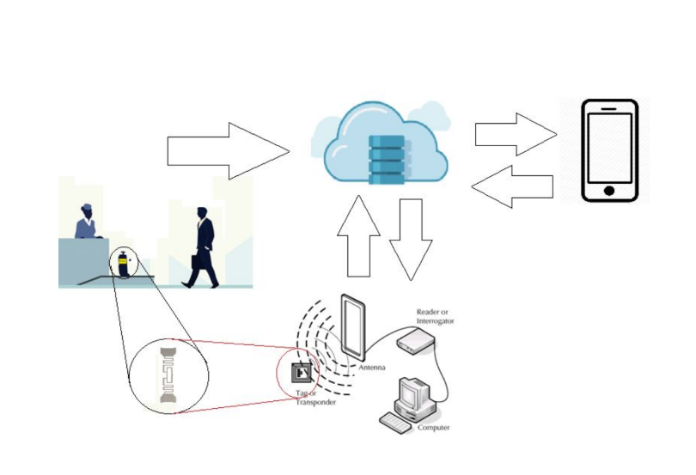

**Fig. Pictorial representation of the workflow proposed by the system.**

**A.Scanning and Management at Checkpoints:**

After sticking the programmed RFID tags to the baggage, it is passed through RFID Scanners. If the specifications mentioned on the tags are not confirmed by the system, the baggage is returned to its previous stage. Its tag is checked and replaced if necessary. The baggage is then checked again by passing through RFID readers and the information is stored in a local server and then loaded onto respective flights .

At the Destination Airport, the aforementioned baggage is offloaded and passed through RFID readers. The identification number of the tags read by the readers is already stored at the local server of Destination Airport. In this way, the authenticity of the offloaded baggage is checked and confirmed, avoiding loss/misplacement of luggage. The baggage passes various checkpoints having RFID readers at each location on the conveyor belt and this will constantly inform the passenger about the status of his baggage.

**B. Database connectivity and Users:**

Once a tag is assigned to a user,he will first receive a confirmation message along with a link to monitor tracking. At the check out point, as the passenger reaches the counter, he will have to enter a unique identification number received by him. This number is checked by the reader and authenticated with the help of information already uploaded on main server at the Arrival Airport. We plan to implement the prototype at two locations namely check in and checkout. The performance monitoring of the proposed system is done with some people with their baggage checked in at one location and undergoing the entire process. Since our main focus is on tag generation at check in and reading ID and checking on the data on server during check out. At each and every checkpoint the user will be notified about the status of his baggage via an SMS.

**Conclusion:**

In today’s hustling life, the security of luggage is one of the most important concerns in the airline industry , due to the repeated loss, thefts and delay in arrival of baggage of passengers. The proposed system aims at developing and providing a working model of baggage tracking system using RFID tags. These will help in tracing bags, locating bags and alerting the aviation staff if baggage is improperly loaded. The main advantage is that the system is optimized, and the passengers need not wait for a prolonged period for their bags to appear on the conveyor belt. They are routed to various counters with high security due to the unique identification number. It is environment friendly as doesn’t require printed paper or paper in any other form. With this design air travel can be more passenger friendly, fast, free, with less queuing and greater security of the passenger. The economic and customer friendly results obtained after deployment of RFID in baggage handling are going to be Magnanimous.

**REFERENCES**

1. Tanvir Ahmed, A Data Warehouse Solution for Analyzing RFID-Based Baggage Tracking Data, IEEE 14th International Conference on Mobile Data Management 2013, Page: 283-292
2. Lee Ye-Won, Choi Yong-Lak, Proposal for Air-Baggage Tracking System Based on IoT, IEEE 9th International Conference on Future Generation Communication and Networking, 2015, Page: 25-28.
3. Mostafa Tavassoli, Abolfazl Rajabi, Mehrdad Javadi, SasanMohammadi, Baggage Traffic Control in Airports making use of RFID Technology, International Journal of Soft Computing and Engineering, Volume-2, Issue-5, November 2012, page: 111-116.
4. Brian Prange , Ziye Xing , Marwan Baraya , Emmanuel Wadieh , Henry Nguyen , Airline Baggage Tracking, ECE 480 ­ Design Team 1, 10/9/2015